NEURAL NETWORKS 2006
Andrea Franceschini
UIN: 655235956

Motif recognition in Protein sequences

ABSTRACT

In this work I designed a MultiLayer Neural Network to solve the problem of finding known motifs in protein sequences. I’ve implemented the network with java programming language and then tested its performance. The network can be trained with known alignments of motif’s amino acid sequences and is able to recognize, given it in input a protein sequence, if and where one of these “classified” motifs occur in the sequence. This network can find significant application in bioinformatics and biomedical research fields.

1. INTRODUCTION

Neural Networks find many interesting applications in Bioinformatics.
With the sequencing of the human genome and with the recent progresses in biological automatic-analysis always more and more data is present in biological databases.
Usually data is present in form of character sequences that represent biological molecules (e.g. amino acid or nucleic acid sequences) and most of the biological databases are public and can be freely accessed by anyone via web.
Analysis of such data is one of the greatest challenges of the so called “post-genomic” era.
Typical problems of biological sequence data analysis are the identification of significant patterns or motifs along a sequence or the characterization of the particular structure in which a protein folds starting from its sequence.
In this work I have designed and implemented a Neural Network to detect known motifs in protein sequences.
The network performs quite well being able to identify the presence of a motif in a biological sequence along with its correct position inside the sequence.
This network may find interesting applications in biomedical and pharmaceutical research; being potentially able to discover the presence of important motifs ina sequence to be used as targets for drug design.
In this paper I describe in deitel my implementation of the network and the results of the perfomance evaluation tests made.
In particular in section 2 I give a brief introduction of molecular biology and explain the motif recognition problem, in section 3 I describe the preproccessing phase needed to convert input data in a suitable format to be given in Input to the network, in section 4 I describe my implementation of the network, in section 5 I describe the sources from which I got the data for training/testing the network, in section 6 I report the results of some performance analysis of the network and in section 7 I will draw some conclusions and future perspective.

2. Molecular Biology Primer (Motif recognition)

Molecular biology is the study of biology at a molecular level and concerns itself with understanding the interactions between the various systems of a cell, including the interrelationship of DNA, RNA and protein synthesis and learning how these interactions are regulated.
Every cell of any organism contains a certain amount of DNA (Deoxyribnucleic acid) which is usually represented by computer scientists with a string on a 4 character alphabet (each character representing one of the four biochemical bases that constitute the DNA filament) . DNA contains the genetic instructions for the biological development of a cell. A small tract of the DNA filament that contains the information needed to build a particular protein is called “gene”.
A protein (figure 1) is a chain made by 20 distinct type of amino acids (one amino acid for each 3 DNA bases).
Proteins (or “gene product”) plays an important role in the organism participating in every process within cells. Many proteins are enzymes that catalyze biochemical reactions, and are vital to metabolism. Other proteins have structural or mechanical functions, such as the proteins in the cytoskeleton, which forms a system of scaffolding that maintains cell shape. Proteins are also important in cell signaling, immune responses, cell adhesion, and the cell cycle.
Proteins usually contains some structural motifs: three-dimensional structural elements or folds within the chain, which appear also in a variety of other proteins.
A structural motif (figure 2) is made by a short sequence of 15-20 amino acids found sufficiently conserved in evolution being fundamental to perform the actual function of the protein. The amino acid sequence of a motif can be found more or less conserved in different proteins: variations may occur in evolution due to mutations, insertions or deletions of amino acids.
A motif can be represented by a multiple alignment (figure 3) of the subsequences relative to portions of the proteins experimentally found to contain it. Many of these motifs have been exerimentally determined and their alignments inserted into suitable databases.

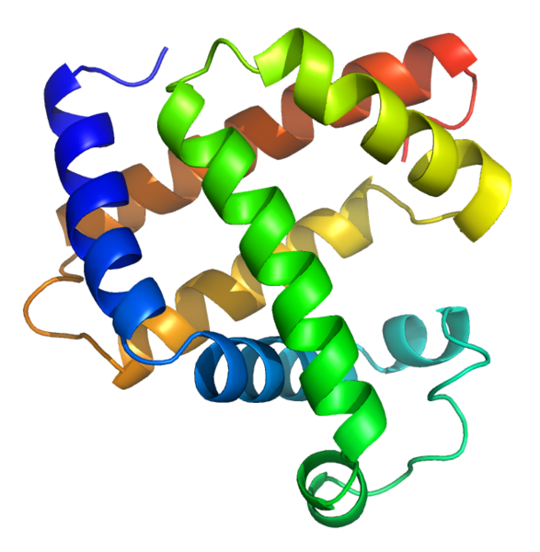
figure 1. 3 D structure of Emoglobin protein

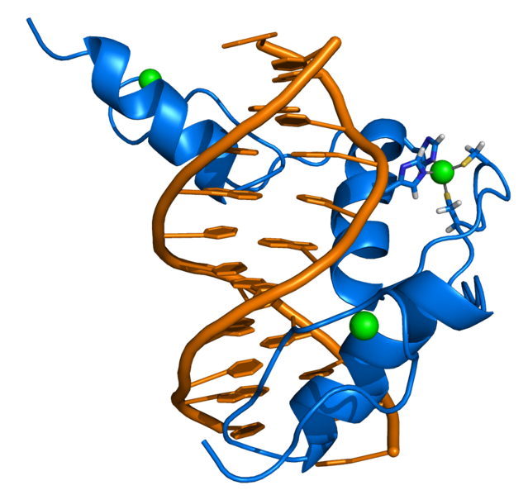

figure 2. Zinc finger motif (3 D structure representation)
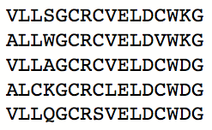

figure 3. sample from a multiple alignment representing a structural protein motif

3. Data sources

There exists many biological databases containing protein motif alignments.
I chose to use the swiss database PROSITE (www.expasy.org/prosite/) to get the alignment of sequences relative to 3 different protein motifs:
- PS50007 phospholipase
- PS51092 Fibronectin type-II
- PS50829 [GYF]
The PSXXXXX number is the identifier of the entry in PROSITE, showned above followed by the name/function of the motif.
I used SwissProt/TrEMBL (www.expasy.org/sprot/) to retrieve 10 protein’s amino acid sequences annotated to contain at least one of the above three motifs.

Other databases from which you can obtain similar data are the following:
- Pfam, Sprintf, Intrpro to retrieve protein motifs’ alignments (often grupped in families or domains)
- NCBI Protein database to retrieve annotated protein sequences

All these databases can be easily queried using suitable web interface and dedicated search engines in order to retrive the data you are interested in.

4. Preprocessing

In order to preproces the data I had to develop an application to convert the amino acid sequences of the proteins to sequences of binary digits. Since there exists only 20 types of amino acids I used a 5 bit representation for each amino acid (tfigure 1).

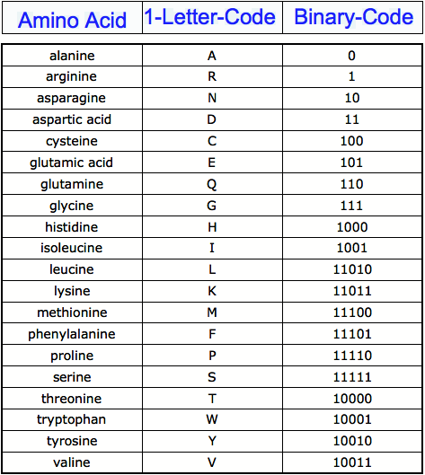

5. The Network

I’ve implemented a standard Back Propagation network with two hidden layer respectively of 7 and 4 neurons and an output layer of two neurons (figure 2).
The network is full connected and takes in input a vector of 80 bits that codes for a sequence of 16 amino acids.

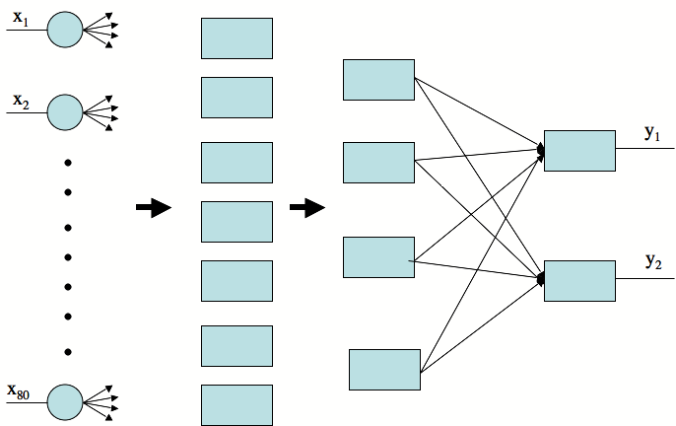

figure 2. Back Propagation Neural Network implemented

The 4 bit output of the network says whether the input matched one of the motif alignments with which the network has been trained, as explained in the following table (figure 3):

OUTPUT | MEANING
00 | The input sequence didn’t match any motif
01 | The input sequence matched motif 1
10 | The input sequence matched motif 2
11 | The input sequence matched motif 3

figure 3. Neural Network’s output

6. Training

In order to train the network I collected the alignments of 3 different motifs (usually composed by 5-10 short sequences of 10-20 characters).
To train the network on the “non recognized” output I randomly generated 300 protein sequences of 16 amino acids using the simplest random model (0.05 probability to have a particular amino acid in a position of the sequence).
My training procedure sets randomly the initial weights of the network and stops after 500 iterations. If the error rate is lower than a certain threshold the training is stopped, otherwise the network is reinizialized with new random weights and the training procedure is automatically restarted.

7. Testing

I tested the network on 10 different protein sequences containing at least one of the three motifs with which I had trained the network.
To test a protein sequences I developed a software that scan the sequence with a “sliding window” of 16 character and that gives each window in input to the Neural Network
I obtained these results:

- 94.6 % of the motifs present in the sequences are correctly recognized
- 3.9 % of the positions in the sequence not containing a motif have been positively recognized

The network performs pretty well, being able to recognize the true motifs most of the times but still report an high false positive rate for this particular application.
I tried to change the topology of the network for example increasing the number of neurons/layers but I didn’t obtain significant improvements and only increase the execution time.

8. Conclusions

In this work I have showned that the network that I have implemented is able to efficiently recognize structural motifs in protein sequences. The network may find important applications in biomedical or pharmaceutical reasearch where the identification of potential structural motif in a new protein sequence can guide the researchers on performing new experiments on that sequence in order to verify the prediction. The identification of structural motifs in a protein sequence may be useful to understand the function of the protein and to develop suitable drugs that target the protein if it is involved in a particular pathology.
Regarding the performance I think that the undesiderable high rate of false positive may be significantly reduced applaying a more sophisticated random model to generate random protein sequences. This would probably lead the network to better classify the sequences that not contain any motif reducing the number of false positives.

7. REFERENCES

Books:
1) Daniel Graupe - Principles of Artificial Neural Networks

Papers:
- [book] Neural Networks and Genome Informatics (Methods in Computational Biology and Biochemistry)
C.H. Wu, J.W. McLarty
- Motif Discoveries in Unaligned Molecular Sequences Using Self-Organizing Neural Networks
IEEE Transactions on Neural Networks Vol 17 N4 July 2006
Bhaskar DasGupta, Derong Liu, Xiaoxu Xiong, Zeng-Guang Hou
- Transcription factor binding site identification using the self-organizing map
BMC Bioinformatics
Shaun Mahony , David Hendrix , Aaron Golden , Terry J. Smith and Daniel S. Rokhsar4,5

